Overview
This document serves as the conclusive summary of the Peer Assessment initiative within the Practical Machine Learning curriculum offered through the Coursera John’s Hopkins University Data Science Specialization. Crafted and executed in RStudio, leveraging its knitr functionalities, the report is presented in both html and markdown formats. The primary objective of this endeavor is to forecast the performance of six participants in completing designated exercises. Employing a machine learning algorithm trained on the ‘classe’ variable within the training dataset, predictions are made on the performance of 20 test cases contained in the test data.

Introduction
In today’s era, the accessibility of devices like Jawbone Up, Nike FuelBand, and Fitbit enables the collection of vast amounts of personal activity data at a relatively low cost. These devices are emblematic of the quantified self movement—a community of enthusiasts who regularly track various metrics about themselves to enhance their health, identify behavioral patterns, or simply due to their fascination with technology. While individuals often quantify the quantity of a particular activity they engage in, they seldom measure the quality of their performance.
This project aims to leverage data gathered from accelerometers placed on the belt, forearm, arm, and dumbbell of six participants. These individuals were tasked with executing barbell lifts both correctly and incorrectly in five distinct manners.
For further details, please refer to the following website: http://groupware.les.inf.puc-rio.br/har.

Data
The training and test datasets for this project can be accessed through the following links:
Training data: https://d396qusza40orc.cloudfront.net/predmachlearn/pml-training.csv
Test data: https://d396qusza40orc.cloudfront.net/predmachlearn/pml-testing.csv
These datasets originate from the following source: http://groupware.les.inf.puc-rio.br/har
The data’s full reference is provided as:
Velloso, E.; Bulling, A.; Gellersen, H.; Ugulino, W.; Fuks, H. “Qualitative Activity Recognition of Weight Lifting Exercises. Proceedings of 4th International Conference in Cooperation with SIGCHI (Augmented Human ’13)”. Stuttgart, Germany: ACM SIGCHI, 2013.

Data Loading and Cleaning
library(lattice)
library(caret)
library(corrplot)
library(randomForest)
library(rattle)
library(RColorBrewer)
library(ggplot2)
library(rpart)
library(rpart.plot)
set.seed(666)
Data loading
# Data loading
trainingdata <- "http://d396qusza40orc.cloudfront.net/predmachlearn/pml-training.csv"
testingdata <- "http://d396qusza40orc.cloudfront.net/predmachlearn/pml-testing.csv"

trainingdataset <- read.csv(url(trainingdata), na.strings = c("NA",""))
testingdataset <- read.csv(url(testingdata), na.strings = c("NA",""))

Dataset Partitioning
After loading the data, we’ll split the training set, using 75% for model training and the remaining 25% for validation.
# Dataset Partitioning
TrainingPart <- createDataPartition(trainingdataset$classe, p=0.75, list=FALSE)
trainingdata <- trainingdataset[TrainingPart, ]
testingdata <- trainingdataset[-TrainingPart, ]
dim(trainingdata)
## [1] 14718 160
dim(testingdata)
## [1] 4904 160
Filtering to the 95% threshhold and removing Nulls/Near-Zero-Variance
# Filtering to the 95% threshold and removing Nulls/Near-Zero-Variance
NearZeroVariables <- nearZeroVar(trainingdata)
trainingdata <- trainingdata[, -NearZeroVariables]
testingdata <- testingdata[, -NearZeroVariables]

Nulls <- sapply(trainingdata, function(x) mean(is.na(x))) > 0.95
trainingdata <- trainingdata[, Nulls == FALSE]
testingdata <- testingdata[, Nulls == FALSE]

# Remove Id Variables
trainingdata <- trainingdata[, -(1:5)]
testingdata <- testingdata[, -(1:5)]

dim(trainingdata)
## [1] 14718 54
dim(testingdata)
## [1] 4904 54
The number of variables has been reduced from 160 to 54.

Model Analysis

Correlation Analysis
# Calculate correlation matrix
correlationmatrix <- cor(trainingdata[, -54])

# Convert correlation matrix to tidy format
correlationmatrix_tidy <- as.data.frame(as.table(correlationmatrix))
colnames(correlationmatrix_tidy) <- c("Variable1", "Variable2", "Correlation")

# Plot heatmap using ggplot2
ggplot(correlationmatrix_tidy, aes(x = Variable1, y = Variable2, fill = Correlation)) +
geom_tile() +
scale_fill_gradient2(low = "blue", high = "red", mid = "white",
midpoint = 0, limit = c(-1,1), space = "Lab",
name="Correlation") +
theme_minimal() +
theme(axis.title.x = element_blank(),
axis.title.y = element_blank(),
axis.text.x = element_text(angle = 90, vjust = 1, size = 6),
axis.text.y = element_text(size = 6)) +
coord_fixed()
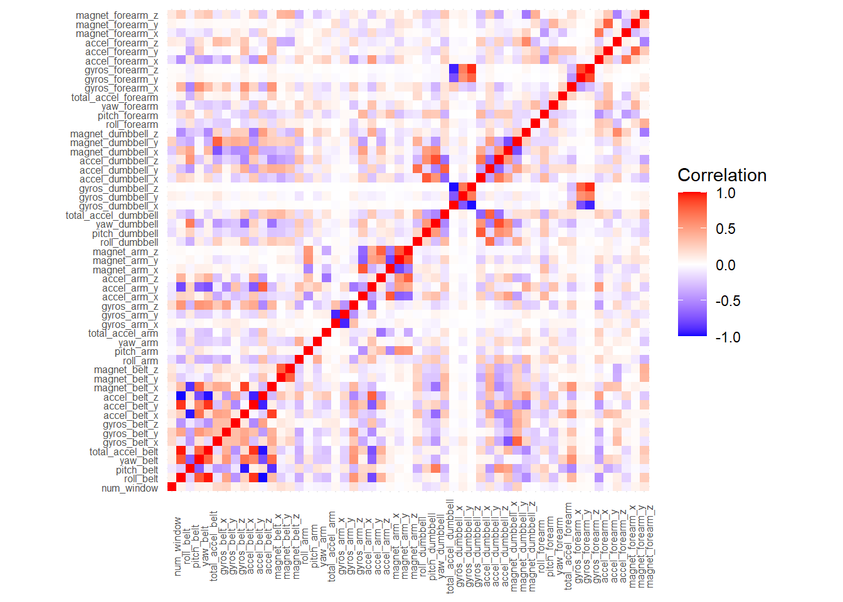
The above correlation matrix shows each cell representing the correlation coefficient between two variables, with color intensity indicating the strength and direction of the correlation. Blue denotes negative correlation, red indicates positive correlation, and white suggests no correlation. Clusters of similarly colored cells highlight groups of correlated variables, facilitating the understanding of relationships between variables for data analysis and modeling.
Prediction Models

Random Forest Model
set.seed(666)
controlrandomforest <- trainControl(method = "repeatedcv", number = 5, repeats = 2)
fitrandomforest <- train(classe ~ ., data = trainingdata, method = "rf",
trControl = controlrandomforest, verbose = FALSE)
fitrandomforest$finalModel
##
## Call:
## randomForest(x = x, y = y, mtry = param$mtry, verbose = FALSE)
## Type of random forest: classification
## Number of trees: 500
## No. of variables tried at each split: 27
##
## OOB estimate of error rate: 0.21%
## Confusion matrix:
## A B C D E class.error
## A 4183 1 0 0 1 0.0004778973
## B 6 2839 2 1 0 0.0031601124
## C 0 4 2560 3 0 0.0027269186
## D 0 0 10 2402 0 0.0041459370
## E 0 0 0 3 2703 0.0011086475

Predictions on Test Data
predict_RF <- predict(fitrandomforest, newdata = testingdata)
confusionmatrixrf <- confusionMatrix(predict_RF, factor(testingdata$classe))
confusionmatrixrf
## Confusion Matrix and Statistics
##
## Reference
## Prediction A B C D E
## A 1395 1 0 0 0
## B 0 948 2 0 0
## C 0 0 853 4 0
## D 0 0 0 799 0
## E 0 0 0 1 901
##
## Overall Statistics
##
## Accuracy : 0.9984
## 95% CI : (0.9968, 0.9993)
## No Information Rate : 0.2845
## P-Value [Acc > NIR] : < 2.2e-16
##
## Kappa : 0.9979
##
## Mcnemar's Test P-Value : NA
##
## Statistics by Class:
##
## Class: A Class: B Class: C Class: D Class: E
## Sensitivity 1.0000 0.9989 0.9977 0.9938 1.0000
## Specificity 0.9997 0.9995 0.9990 1.0000 0.9998
## Pos Pred Value 0.9993 0.9979 0.9953 1.0000 0.9989
## Neg Pred Value 1.0000 0.9997 0.9995 0.9988 1.0000
## Prevalence 0.2845 0.1935 0.1743 0.1639 0.1837
## Detection Rate 0.2845 0.1933 0.1739 0.1629 0.1837
## Detection Prevalence 0.2847 0.1937 0.1748 0.1629 0.1839
## Balanced Accuracy 0.9999 0.9992 0.9983 0.9969 0.9999

Decision Tree Model
set.seed(666)
fit_decision_tree <- rpart(classe ~ ., data = trainingdata, method="class")

rpart.plot(fit_decision_tree, box.palette = "RdYlGn", shadow.col = "gray")
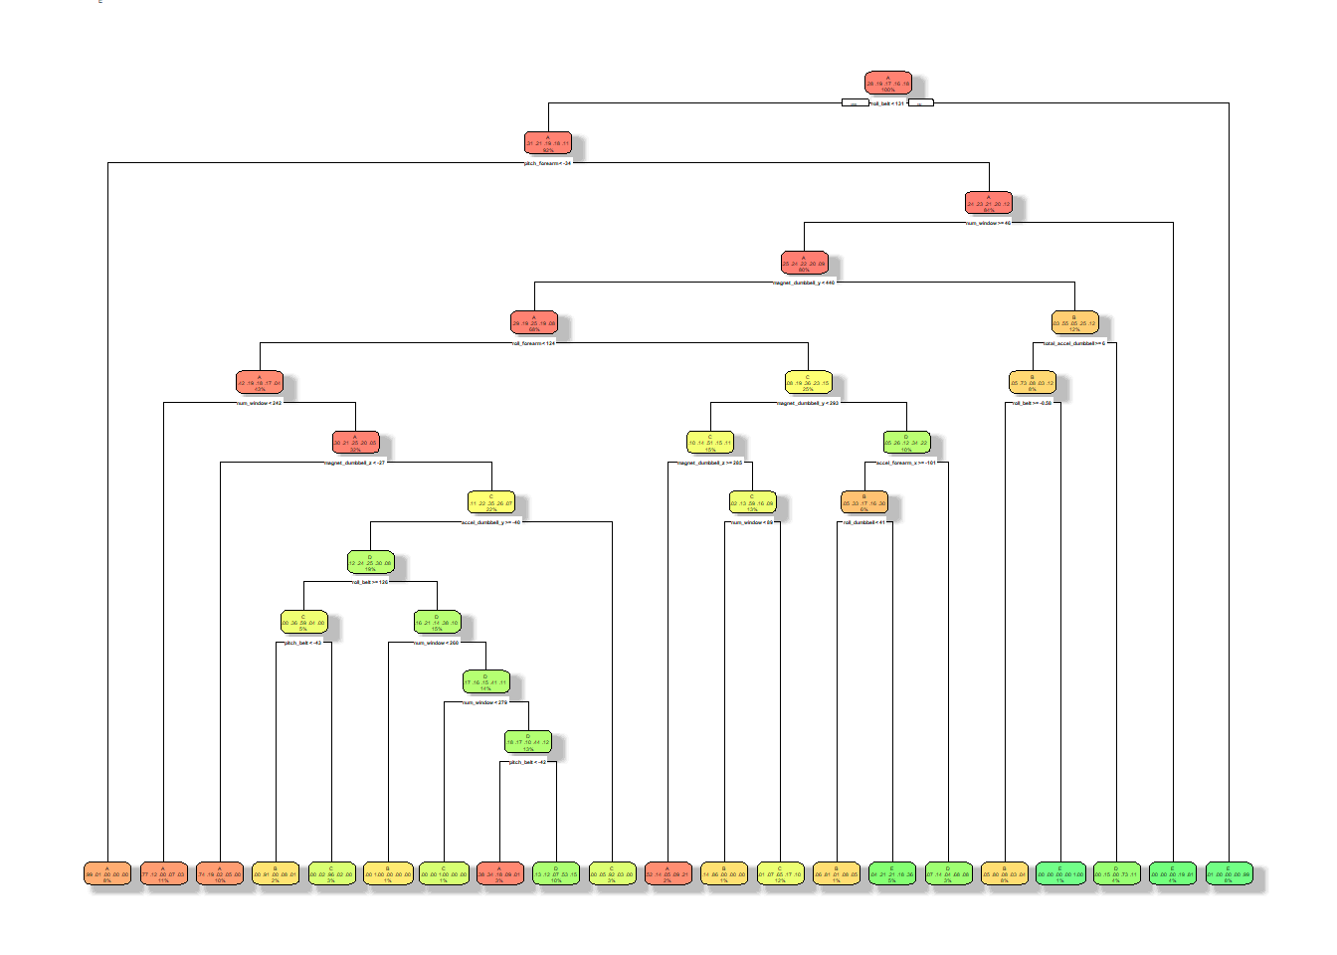

Predictions on Test Data
predict_decision_tree <- predict(fit_decision_tree, newdata = testingdata, type="class")
conf_matrix_decision_tree <- confusionMatrix(predict_decision_tree, factor(testingdata$classe))
conf_matrix_decision_tree
## Confusion Matrix and Statistics
##
## Reference
## Prediction A B C D E
## A 1253 203 33 72 45
## B 35 513 17 13 15
## C 7 54 694 118 56
## D 77 130 57 515 94
## E 23 49 54 86 691
##
## Overall Statistics
##
## Accuracy : 0.7476
## 95% CI : (0.7351, 0.7597)
## No Information Rate : 0.2845
## P-Value [Acc > NIR] : < 2.2e-16
##
## Kappa : 0.6794
##
## Mcnemar's Test P-Value : < 2.2e-16
##
## Statistics by Class:
##
## Class: A Class: B Class: C Class: D Class: E
## Sensitivity 0.8982 0.5406 0.8117 0.6405 0.7669
## Specificity 0.8994 0.9798 0.9420 0.9127 0.9470
## Pos Pred Value 0.7802 0.8651 0.7470 0.5899 0.7652
## Neg Pred Value 0.9569 0.8989 0.9595 0.9283 0.9475
## Prevalence 0.2845 0.1935 0.1743 0.1639 0.1837
## Detection Rate 0.2555 0.1046 0.1415 0.1050 0.1409
## Detection Prevalence 0.3275 0.1209 0.1894 0.1780 0.1841
## Balanced Accuracy 0.8988 0.7602 0.8768 0.7766 0.8570

Model Accuracy
In this report, the Random Forest model demonstrates the highest accuracy, achieving a remarkable value of 99.84%. We can present the model’s predictions confidently based on this performance.
# Get predictions for the 20 observations of the original pml-testing.csv

predictionmodel <- as.data.frame(predict(fitrandomforest, newdata = testingdataset))
predictionmodel
## predict(fitrandomforest, newdata = testingdataset)
## 1 B
## 2 A
## 3 B
## 4 A
## 5 A
## 6 E
## 7 D
## 8 B
## 9 A
## 10 A
## 11 B
## 12 C
## 13 B
## 14 A
## 15 E
## 16 E
## 17 A
## 18 B
## 19 B
## 20 B

